Week 4 Day 1 Task 3

Step 1: Create the VPC
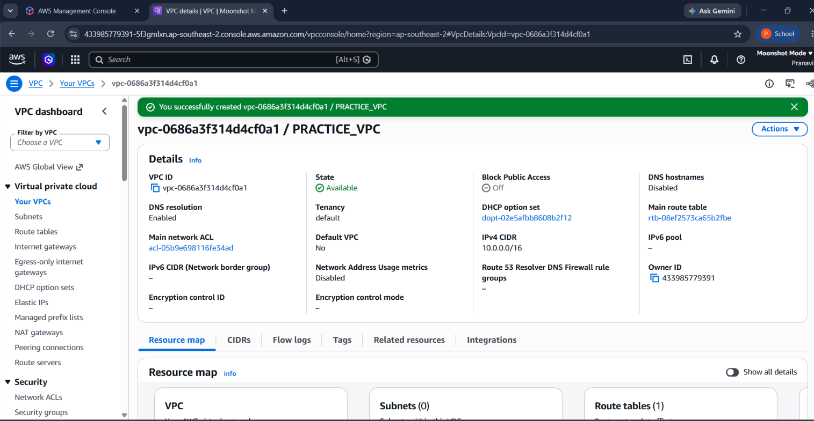

Step 2: Create the Public Subnet
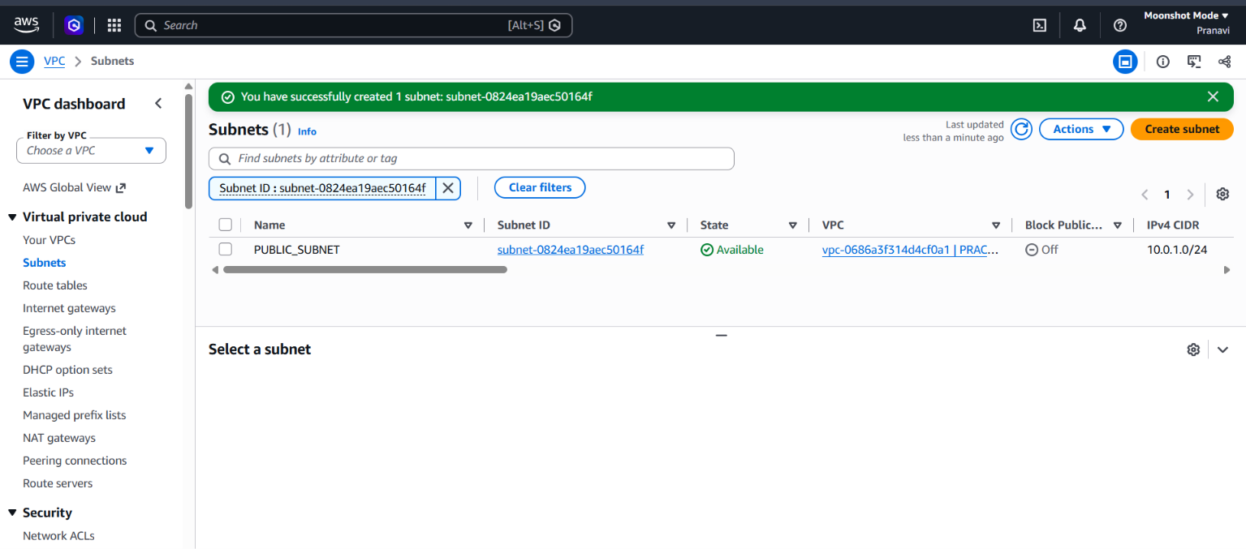
Enable Auto-assign Public IPv4
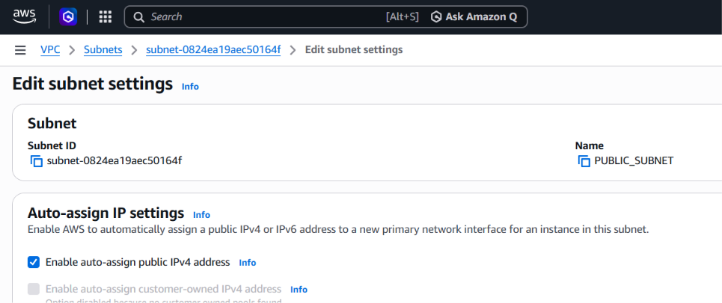
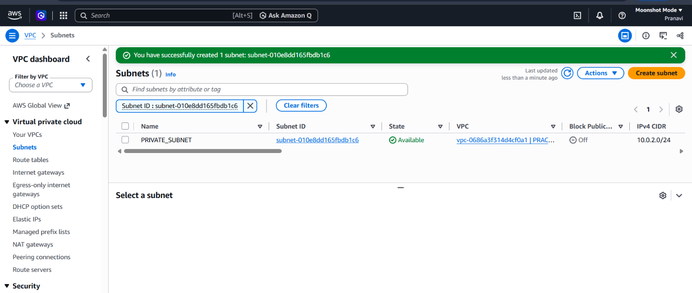
Do not enable auto-assign public IPv4 for the private subnet.

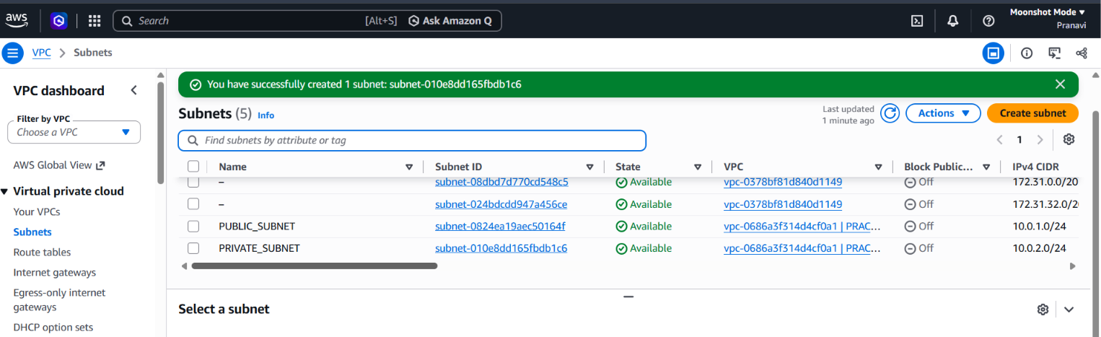PUBLIC AND PRIVATE SUBNET CREATED
Step 5: Create the Internet Gateway
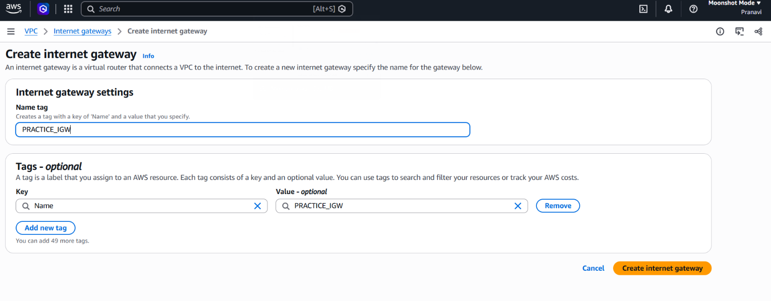
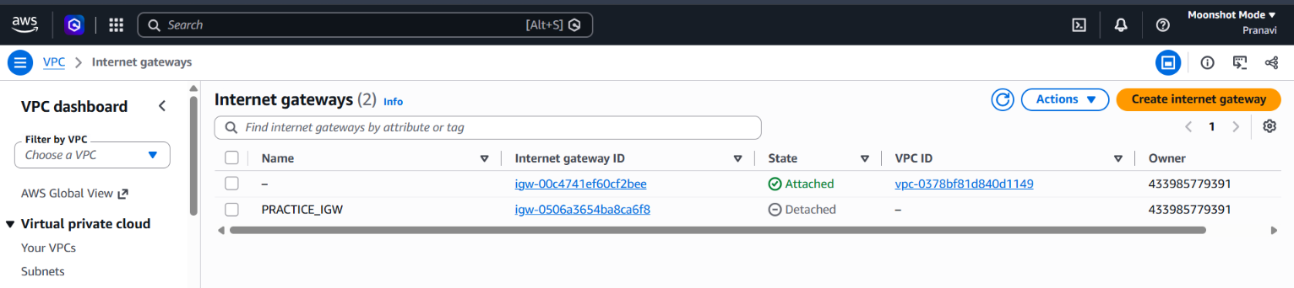
Attach to vpc
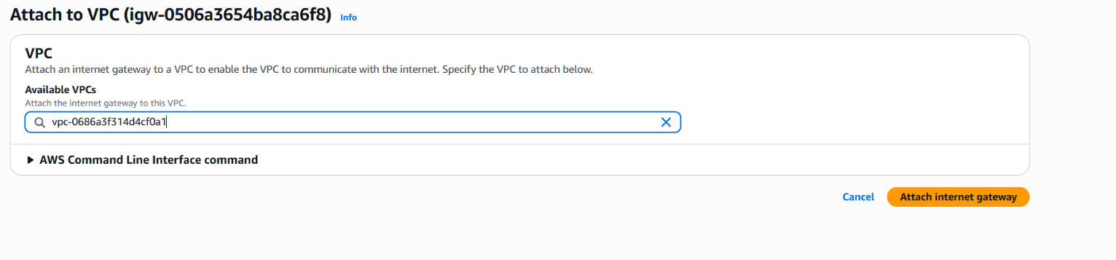
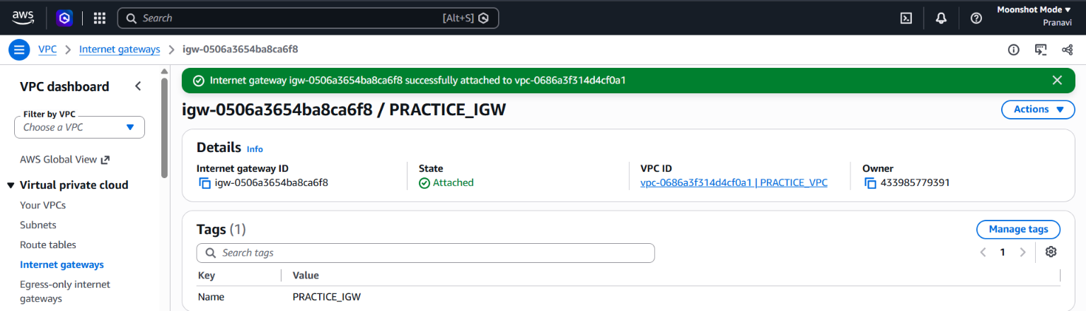
Attached
Step 6: Create the Public Route Table (PUB-RT)
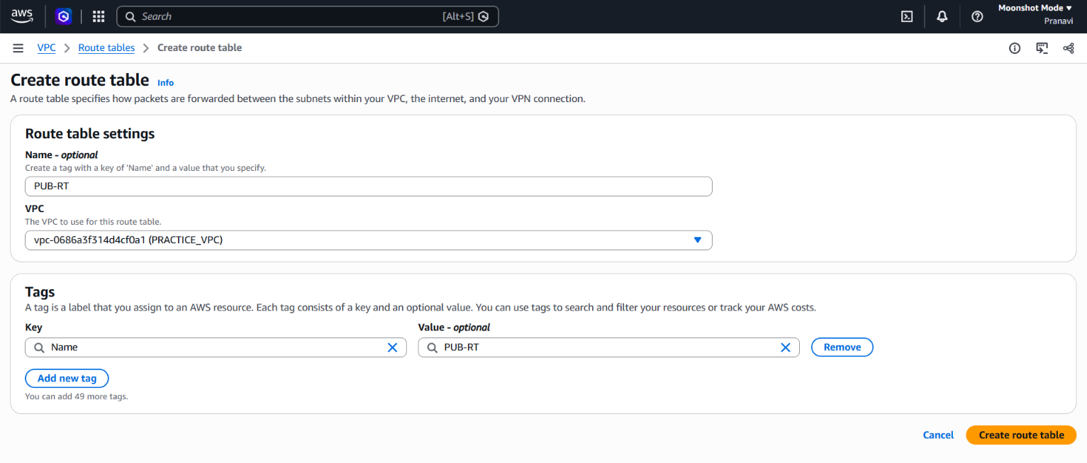
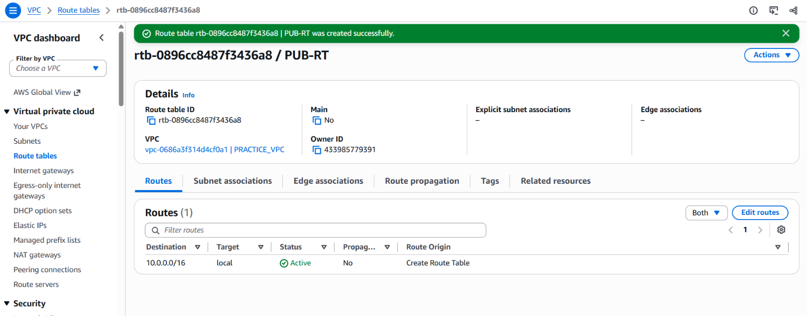
CREATED ROUTE TABLE FOR PUBLIC

Step 7: Add the Internet Gateway Route
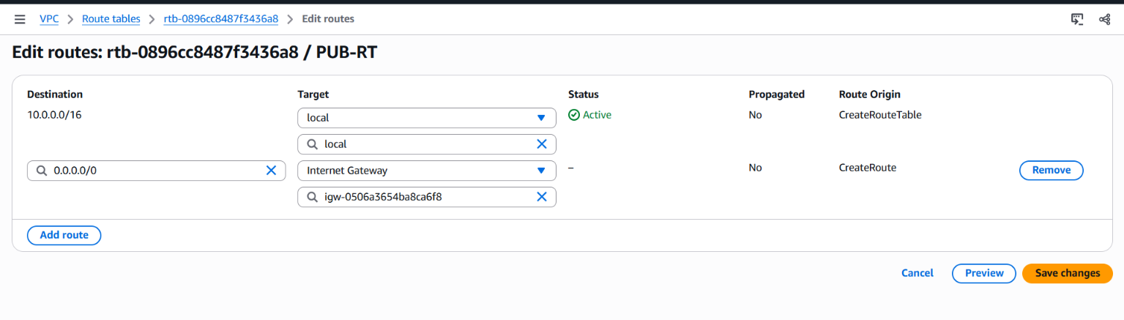
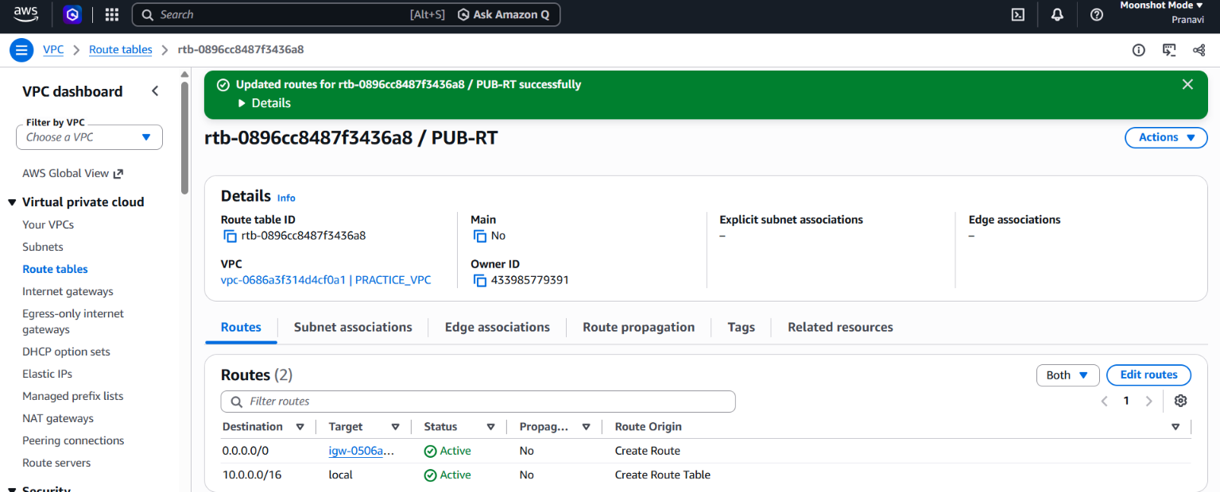

Step 8: Associate Public Subnet
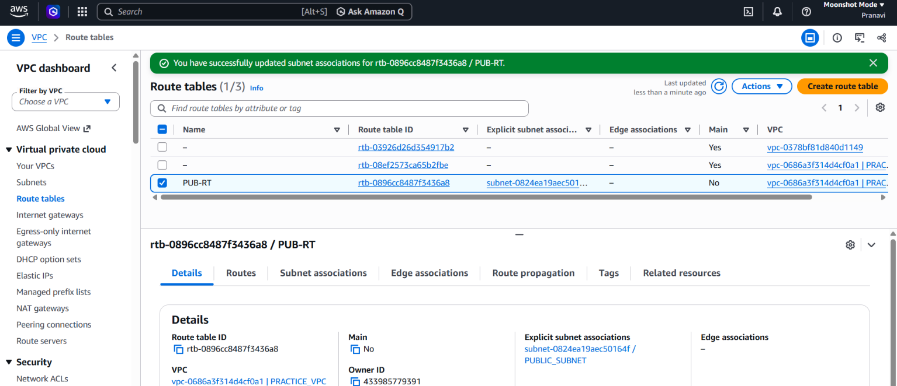
ASSOCIATED

Step 9: Add IGW Route
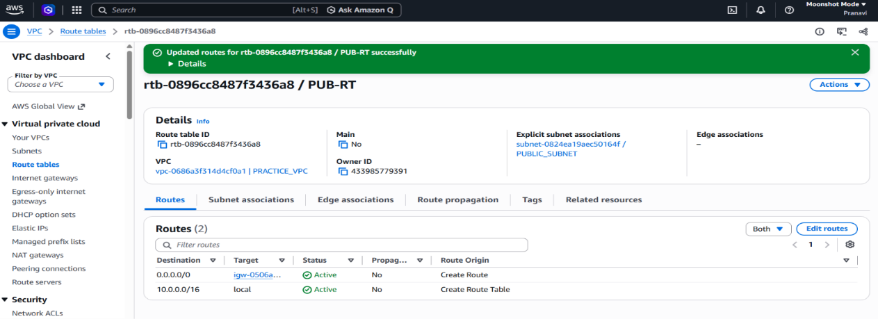

Step 10: Allocate an Elastic IP
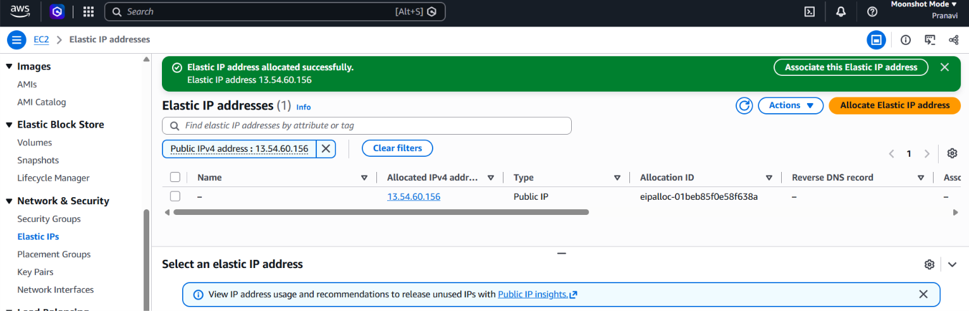
Allocated
• Elastic IP: 13.54.60.156
• Region: Sydney (ap-southeast-2)
• Allocation ID: eipalloc-01beb85f0e58f638a

Step 12: Create the NAT Gateway
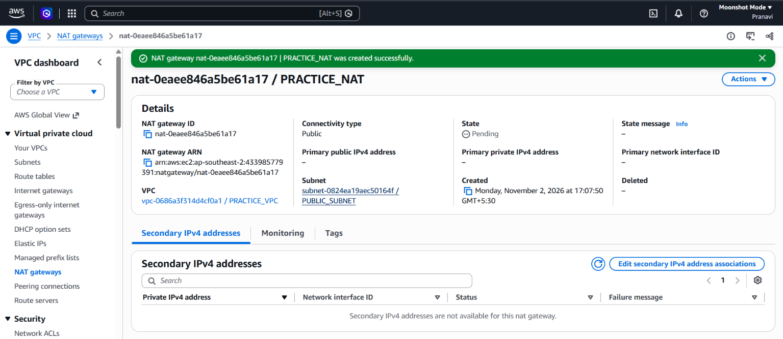
CREATED NAT gateway

Create the Private Route Table
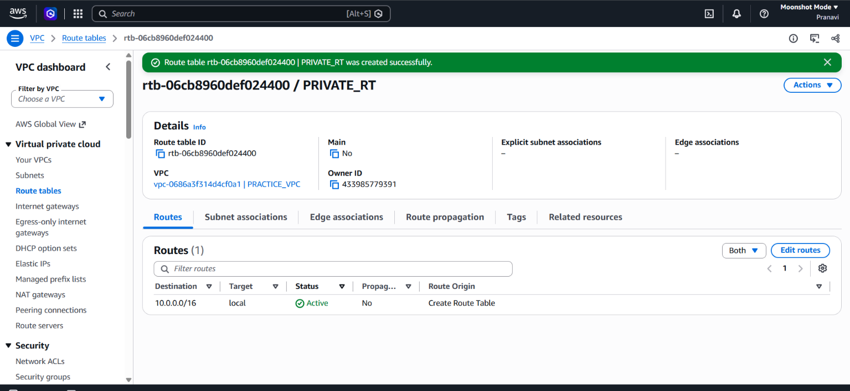
Add NAT Gateway Route to PRIVATE-RT
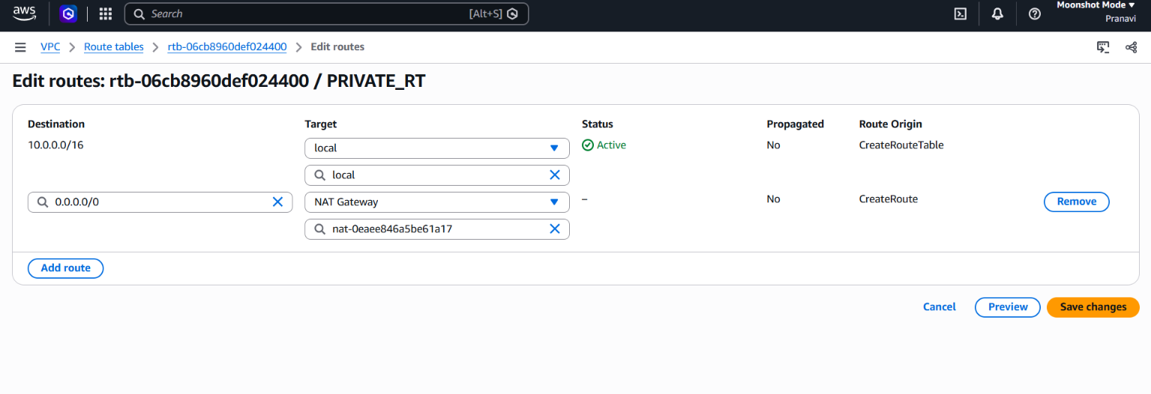
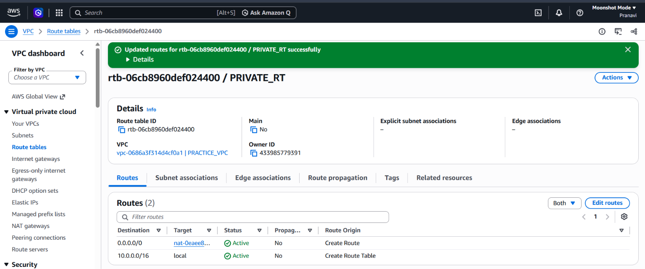

Associate PRIVATE_SUBNET
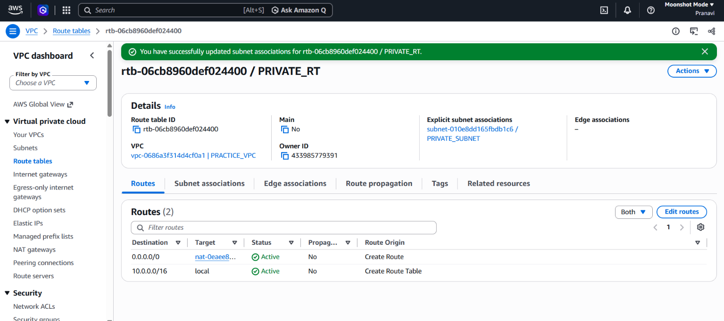

Create the Public Security Group
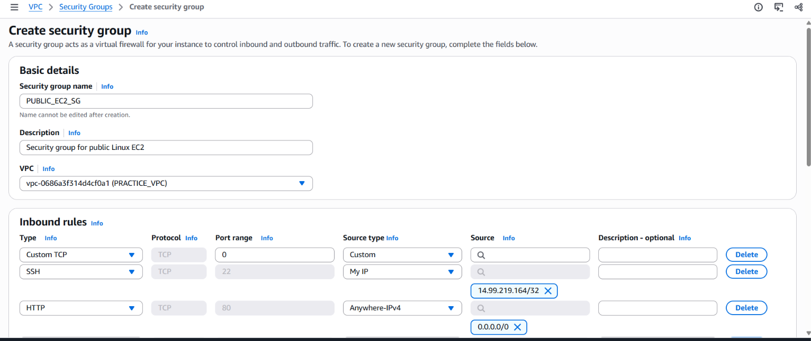
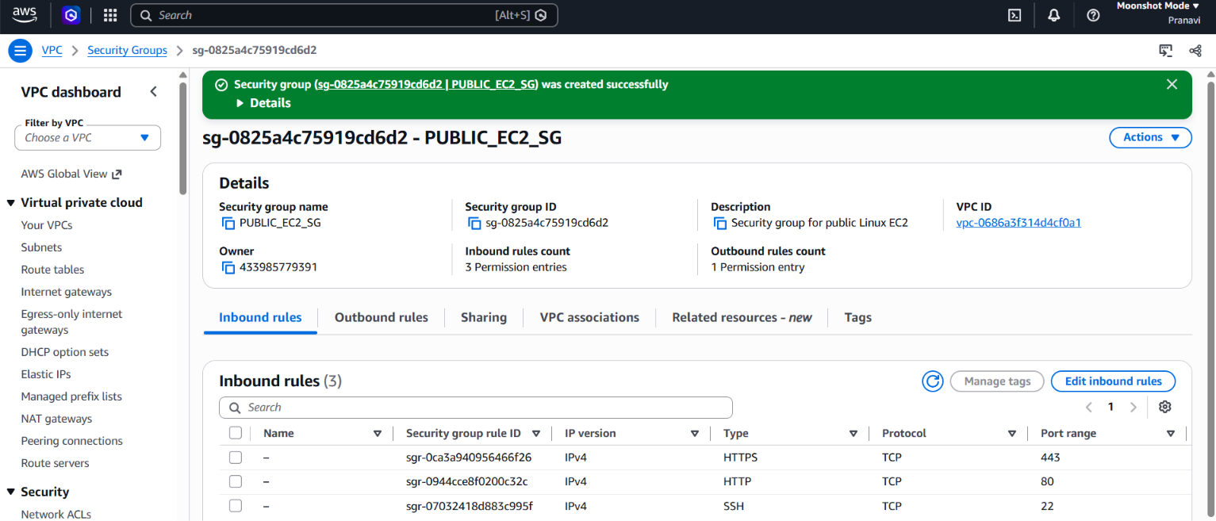
CREATED SECURITY GROUP FOR PUBLIC

Create the Private Security Group
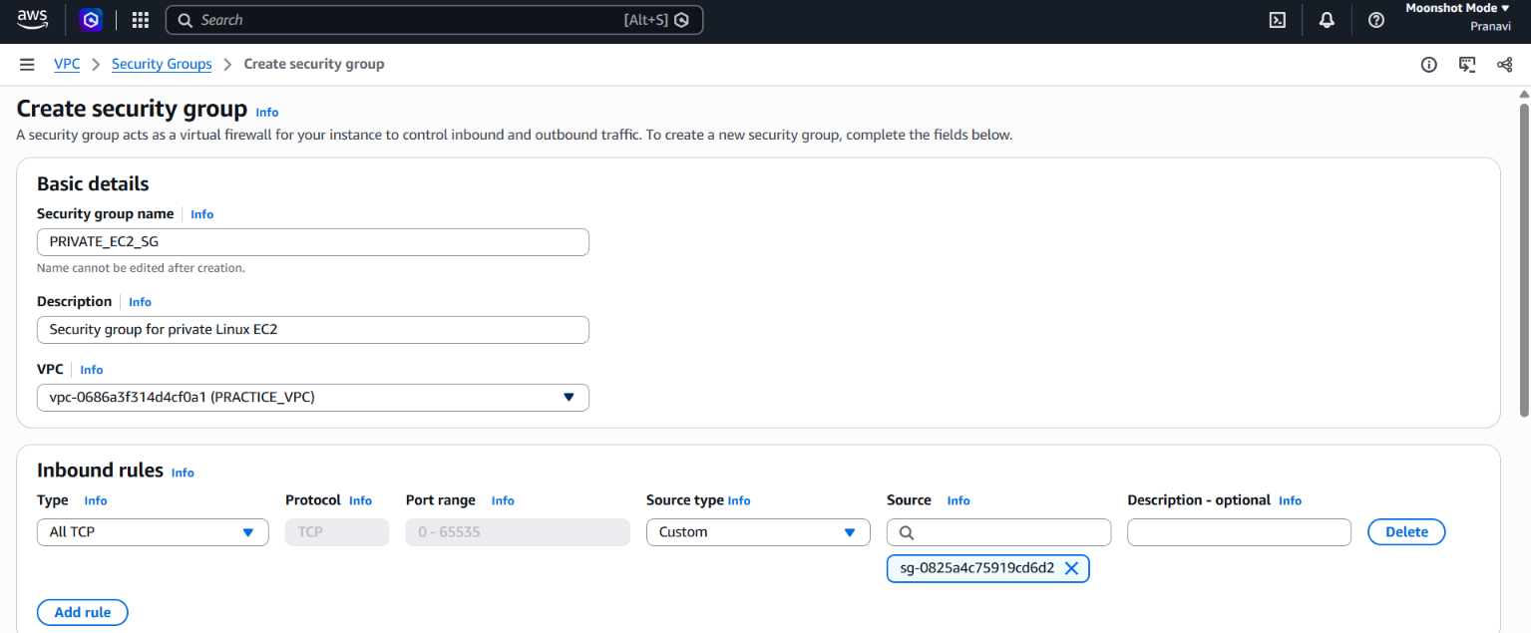
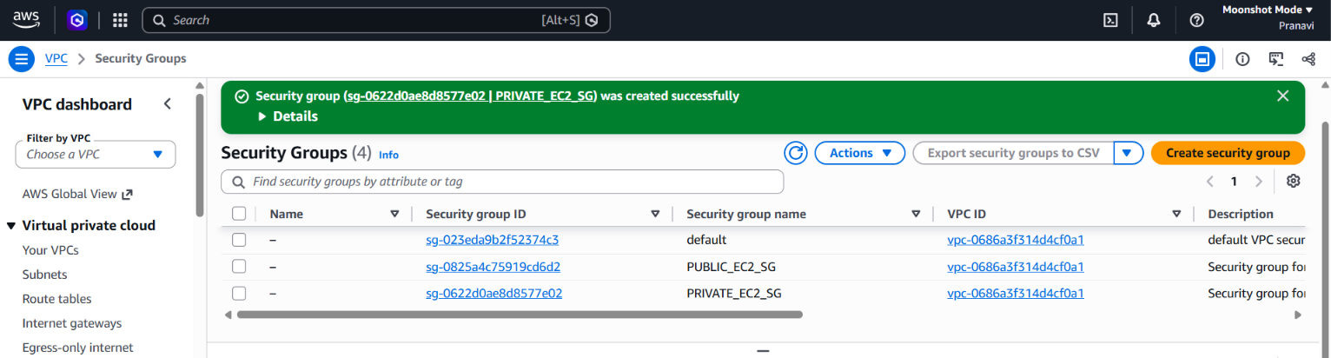
SECURITY GROUPS CREATED
Launch Public Linux EC2
PUBLIC INSTANCE CREATED
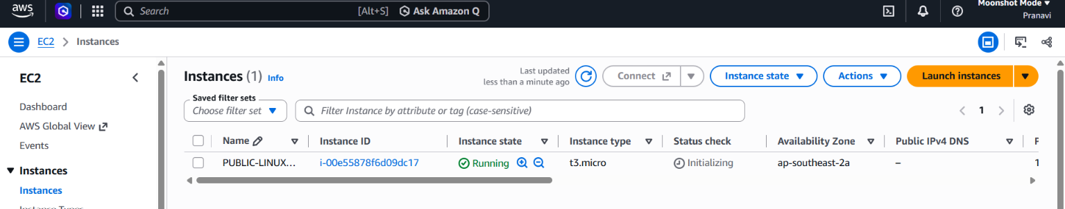

Launch Private Linux EC2
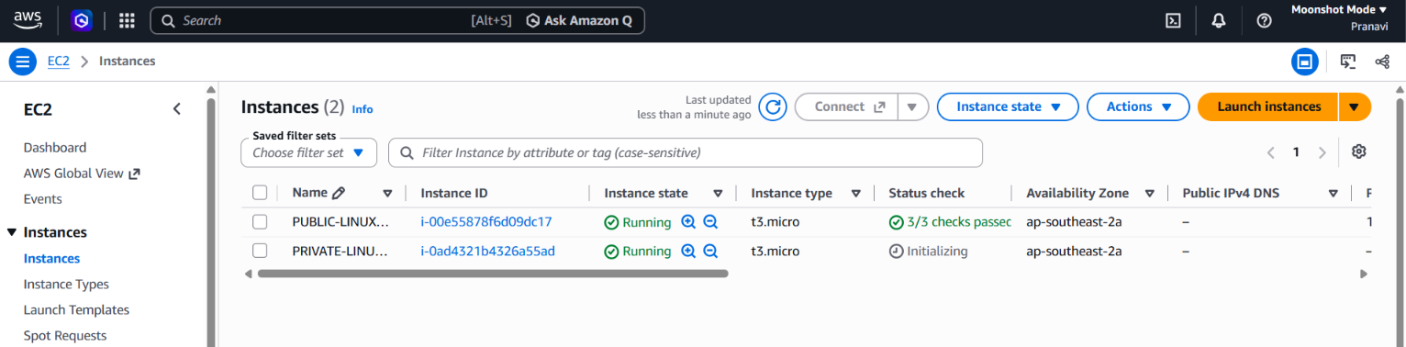
Verify EC2 networking
Public EC2
- Confirm:
  - VPC: PRACTICE_VPC
  - Subnet: PUBLIC_SUBNET
  - Public IPv4 address: assigned
  - Security group: PUBLIC_EC2_SG
Private EC2
- Confirm:
  - VPC: PRACTICE_VPC
  - Subnet: PRIVATE_SUBNET
  - Public IPv4 address: None
  - Security group: PRIVATE_EC2_SG

Connect to the Public Linux EC2
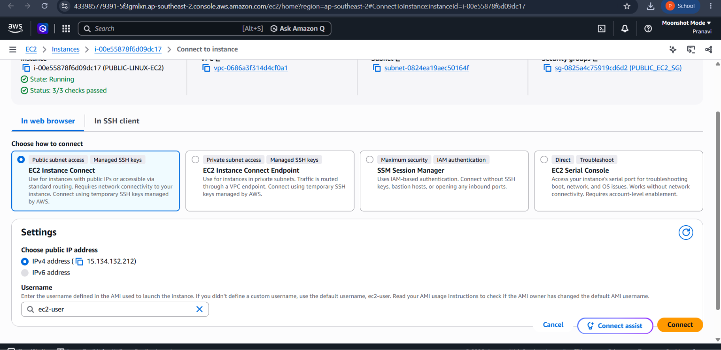
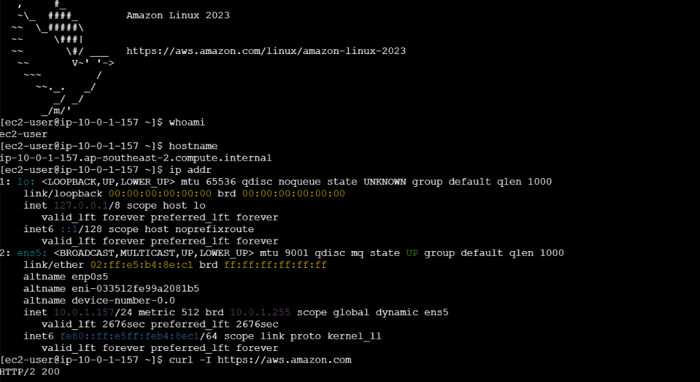
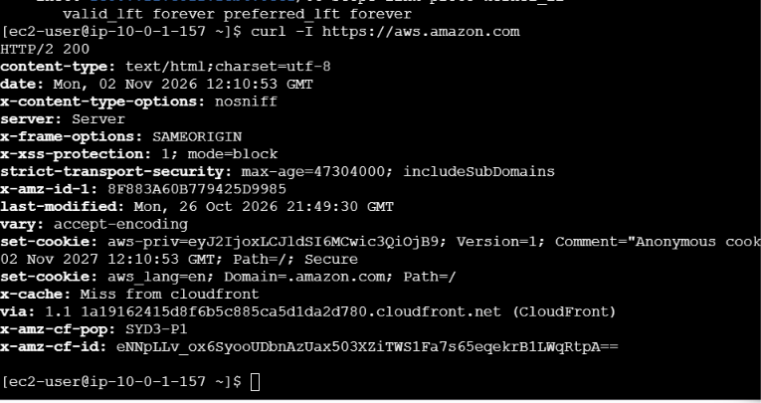
Public ec2 is connecting good
Now connecting private ip through public ip
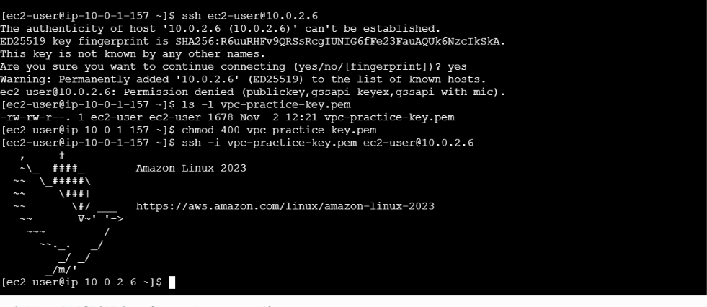
successfully connected from public to private

Verify the Private EC2


